MindCare
(Student Mental Health Support Application)
A
Project Report
submitted in partial fulfillment of the
requirements for the award of the degree of

BACHELOR OF TECHNOLOGY
in
COMPUTER SCIENCE & ENGINEERING
by

Name | Roll No.
Astha Gupta | R2142230703
Aastha Jaiswal | R2142230323
Muskan Mittal | R2142231569

under the guidance of
Mr. Vishal Kumar Lohan


School of Computer Science
University of Petroleum & Energy Studies
Bidholi, Via Prem Nagar, Dehradun, Uttarakhand
May – 2026

CANDIDATE’S DECLARATION

We hereby certify that the project work entitled “ MindCare” in partial fulfilment of the requirements for the award of the Degree of BACHELOR OF TECHNOLOGY in COMPUTER SCIENCE AND ENGINEERING with specialization in FULLSTACK_AI and submitted to the Department of Systemics, School of Computer Science, University of Petroleum & Energy Studies, Dehradun, is an authentic record of my/ our work carried out during a period from January, 2026 to May, 2026 under the supervision of Mr. Vishal Kumar Lohan , Designation and Affiliation

The matter presented in this project has not been submitted by me/ us for the award of any other degree of this or any other University.

(Astha Gupta Sap id - 500121750)
(Aastha Jaiswal Sap id – 500119719)
(Muskan Mittal Sap id - 500124380)

This is to certify that the above statement made by the candidate is correct to the best of my knowledge.

Date: 4/05/2026 ( Mr. Vishal Kumar Lohan)
Project Guide

ACKNOWLEDGEMENT

We wish to express our deep gratitude to our guide Mr. Vishal Kumar Lohan, for all advice, encouragement and constant support he/she has given us throughout our project work. This work would not have been possible without his support and valuable suggestions.
We sincerely thanks to our respected Dr. Christalin Nelson S., Head Department of SOCS, for his great support in doing our project in MindCare.
We are also grateful to Dean SoCS UPES for giving us the necessary facilities to carry out our project work successfully. We also thanks to our Course Coordinator, (NAME) and our Activity Coordinator Deepa Rani for providing timely support and information during the completion of this project.
We would like to thank all our friends for their help and constructive criticism during our project work. Finally, we have no words to express our sincere gratitude to our parents who have shown us this world and for every support they have given us.

Name | Astha Gupta | Aastha Jaiswal | Muskan Mittal
Roll No. | R2142230703 | R2142230323 | R2142231569

ABSTRACT

“MindCare” – The Holistic Mental Health and Wellness Companion is a project designed to address the increasing complexities of mental well-being, emotional regulation, proactive self-care, and personalized therapeutic support.
A mental wellness platform is a digital ecosystem that provides users with tools for emotional monitoring and psychological resilience without requiring immediate clinical intervention. These platforms are engineered to offer a safe, unstructured space for users to track their mental state and engage in wellness activities autonomously.
The goal of this project is to design and build a cross-platform mobile application that serves as a personal mental health assistant. The application must be able to track user moods in real-time, provide AI-driven conversational support, offer structured wellness exercises (such as breathing and grounding techniques), and facilitate a seamless connection between users and professional therapists.
The system is built using a React Native frontend and a Node.js/Express backend. It integrates LangChain and Google GenAI for its core intelligent component, an AI chatbot named "Tink." Data persistence is managed through MongoDB, while Pinecone is utilized as a vector database to enable context-aware AI interactions, ensuring a highly personalized user experience.
The application is programmed to utilize advanced sentiment analysis for mood tracking and provides automated interventions based on user input. Therapeutic features like guided journaling, affirmations, and fitness coaching are integrated into a single interface. Once the system detects high stress levels, grounding techniques and crisis resources are prioritized to assist the user in regaining emotional stability.
One possible implementation of a digital wellness companion is to provide a preventative framework for mental health management. This function is useful in various sectors, including:
- Personal Self-Care (Daily mood tracking and journaling)
- Clinical Support (Bridging the gap between patients and therapists)
- Corporate Wellness (Employee mental health monitoring)
- Crisis Management Systems
  - Emergency Resource Access
  - Immediate Grounding Interventions
  - AI-based Emotional First Aid

TABLE OF CONTENTS
S. No | Contents | Page No
1. | INTRODUCTION | 1
1.1 | Evolution of Digital Mental Healthcare | 1
1.2 | Requirement Analysis | 1
1.3 | Objectives | 1
1.4. | Scope of the Project | 2
2 | SYSTEM ANALYSIS | 3
2.1 | Existing System | 3
2.2 | Motivations | 3
2.3 | Proposed System | 3
2.4 | Modules | 3
3 | DESIGN | 5
3.1 | System Architecture & Modeling | 5
3.2 | Use Case Model for Requirement Analysis | 5
3.3 | The Design Model | 6
3.4 | Object and Class Design | 7
3.5 | State Transition | 8
3.6 | Activity Diagram | 11
4 | MINDCARE | 12
4.1 | MindCare Application Overview | 12
4.2 | LangChain & GenAI – The System’s Brain | 12
4.3 | Developing the MindCare Environment | 12
4.4 | The Interaction Layer – React Native UI Components | 14
4.5 | The "Sensors" – Sentiment Analysis Engine | 14
4.6 | Real-time Monitoring – Threshold Detection | 15
5 | Implementation | 16
5.1 | Emotional State Mapping using Sentiment Scoring | 16
5.2 | Operational Scenarios | 16
5.3 | Behavioral Algorithms | 16
6 | Output screens | 19
7 | Limitations and Future Enhancements | 21
7.1 | Current Limitations | 21
7.2 | Future Enhancements | 22
8 | Conclusion | 24
8.1 | Summary of Work Done | 24
8.2 | Achievement of Objectives | 24
8.3 | Key Learnings | 24
8.4 | Social Impact and Relevance | 25
8.5 | Final Remarks | 25
 | APPENDIX A: MINDCARE APPLICATION COMPONENTS AND CONFIGURATION | 26
 | APPENDIX B: API RESPONSE CODES AND ERROR REFERENCE | 28
 | APPENDIX C: DEVELOPMENT GUIDELINES AND BEST PRACTICES | 30
 | REFERENCES | 32

LIST OF FIGURES
S. No. | Figure | Page No
3 | Chapter 3
3.1 | Use Cases Model for the System | 5
3.2 | Sequence Diagram | 6
3.3 | Class Diagram | 7
3.4 | State Transition: Mood Detection Behavior | 8
3.5 | State Transition: App Feature Navigation | 9
3.6 | State Transition: Crisis Interruption | 9
3.7 | State Transition: Emotional Recovery | 10
3.8 | Activity Diagram for the System | 11
4. | Chapter 4
4.1 | MindCare App Logo and Dashboard | 12
4.2 | Pinecone Vector Storage Structure | 12
4.3 | Node.js Backend & API Routes | 13
4.4 | React Native Codebase Structure | 13
4.5 | Metro Bundler Console Output | 14
4.6 | Sentiment Detection Logic using NLP | 14
4.7 | Mood Intensity Mapping Graph | 15
4.8 | Real-time Stress Level Threshold Monitor | 15
5 | Chapter 5
5.1 | Emotional Journey Graph (Stable Baseline) | 16
5.2 | Emotional Journey Graph (With Obstacles) | 16
5.3 | Scenario-1: Sentiment-Based Support Flow | 17
5.4 | Scenario-2: Pattern-Based Recommendation | 17
5.5 | Scenario-3: Holistic Wellness Scanning | 18

- INTRODUCTION

1.1 Evolution of Digital Mental Healthcare

- Background and Context
The global landscape of mental health has undergone a significant change in recent years, with increasing recognition of the importance of emotional well-being alongside physical health. Despite this, millions of individuals remain disadvantaged due to social stigma, high medical costs, and a shortage of mental health professionals. Digital health interventions have emerged as an important solution to bridge this gap.

- The Role of AI in Wellness
Artificial Intelligence has transformed from a purely analytical tool to a helpful companion in the wellness sector. Modern applications now leverage natural language processing (NLP) to provide empathetic, real-time responses to users in crisis. MindCare uses these advancements to create a proactive rather than reactive mental health support system.

1.2. Requirement Analysis

- Problem Statement
Then, the user could seamlessly shift between monitoring their daily wellness, journaling their thoughts, receiving conversational support, and connecting to a therapist—removing the need to use multiple applications for each purpose.

- Targeted Users
The project primarily targets students, working professionals, and individuals looking for a private, low-barrier entry point into mental health management. By providing an autonomous tool, MindCare reduces the initial friction associated with seeking psychological help.

1.3. Objectives

- Main Objective
The MindCare project aims to use AI technology to build a mobile application that will integrate all aspects of mental, emotional, and therapeutic care.
- Sub-Objectives
- Develop a mood-check system to visualize users’ emotional data over designated periods of time.
- Create “Tink,” an integrated, intelligent emotional support chatbot built on LangChain and Google GenAI.
- Integrate structured exercises, including guided therapeutic breathing, grounding activities, and gratitude journaling, to promote emotional wellness and balance.
- Provide a safe channel for interaction between clients and employed licensed practitioners.

1.4. Scope of the Project

- Functional Boundaries
MindCare is designed to be a first-line support and well-being tracking tool. Although it provides AI-powered interactions and resources, it is intended to complement, not replace, clinical psychiatric diagnosis. The project focuses on data-driven insights and immediate coping mechanisms to improve the quality of daily life of the user.
2.1. Existing System

- Technical Framework
React Native offers cross-platform access, Node.js provides a flexible backend, and Pinecone Vector Database ensures personalized, context-based responses from the AI, grounded in therapeutic best practices. So, this project employs a contemporary technology stack, project describing its component functionalities.

- SYSTEM ANALYSIS

Traditional approaches to mental health management rely primarily on face-to-face therapy sessions and manual self-tracking methods. Currently, many users use simple note-taking apps or physical journals to record their feelings. However, these existing methods have several limitations:
- Lack of immediate response: Standard magazines may not provide feedback or emotional support during a crisis.
- High barrier to entry: Occupational therapy is often expensive and requires scheduling, making it inaccessible for immediate, daily needs.
- Data fragmentation: Users often have their wellness data (fitness, mood, thoughts) spread across multiple unrelated platforms.
- Stigma and confidentiality: Many individuals avoid seeking help due to the perceived stigma of attending a clinic.

2.2. Motivations
The main goal of MindCare is to facilitate access to mental health support through technology. The development of Large Language Models (LLMs) and mobile computing paves the way for a sentimental and personalized companion that can be present 24/7. What MindCare aims for is to create a "safe space" that gives data-informed insight and AI-driven therapy that works to inspire and encourage the user to be more engaged with their mental health.

2.3. Proposed System
The proposed system, MindCare, is an integrated mental wellness ecosystem built on a mobile-first architecture. It integrates proactive mood monitoring with responsive AI conversational support. Unlike the existing system, MindCare provides:
- 24/7 AI Interaction: An intelligent chatbot (Tink) that provides immediate emotional support.
- Holistic data integration: A single platform for journaling, mood tracking, and fitness monitoring.
- Contextual Intelligence: Uses vector databases to "remember" user history and provide more relevant support over time.
- Professional Connectivity: A secure bridge for users to transition from self-care to professional therapy when needed.

2.4. Modules

- AI Conversational Engine (Tink)
This is the main intelligence module of the app. It uses Langchain and Google GenAI to process user messages and provide empathetic responses. This module also interacts with the Pinecone vector database to maintain long-term context and ensure continuity of interaction.

- Emotional Analytics & Mood Tracker
This module handles the collection and visualization of the user's emotional state. It allows users to log their mood daily and generates graphical insights (trends, triggers) to help users understand their psychological patterns over weeks or months.

- Therapeutic Toolkit (Activities)
This module includes various non-interactive wellness tools:
- Guided Breathing: Interactive animations to help users control their heart rate.
- Grounding exercise: A technique for bringing attention back to the present moment during anxiety.
- Gratitude Journal: A dedicated space for positive reflection.

- Therapist-Patient Interface
A special module designed for health care professionals. It allows physicians to view authorization data from their patients, manage appointments, and provide direct feedback through a dedicated dashboard.

- User Management & Security
This module handles secure authentication using JWT (JSON Web Token) and bcryptjs for password hashing. This ensures that sensitive mental health data is encrypted and only accessible to authorized users.

- DESIGN

3.1. System Architecture & Modeling

Architecture and Behavioral Logic
MindCare's design is centered around a responsive behavior model. Unlike traditional static apps, MindCare behaves like a living assistant. It uses a client-server architecture where the mobile frontend handles the user experience, while the backend manages "cognitive" tasks such as sentiment analysis and episodic memory.

3.2. Use Case Model for Requirement Analysis

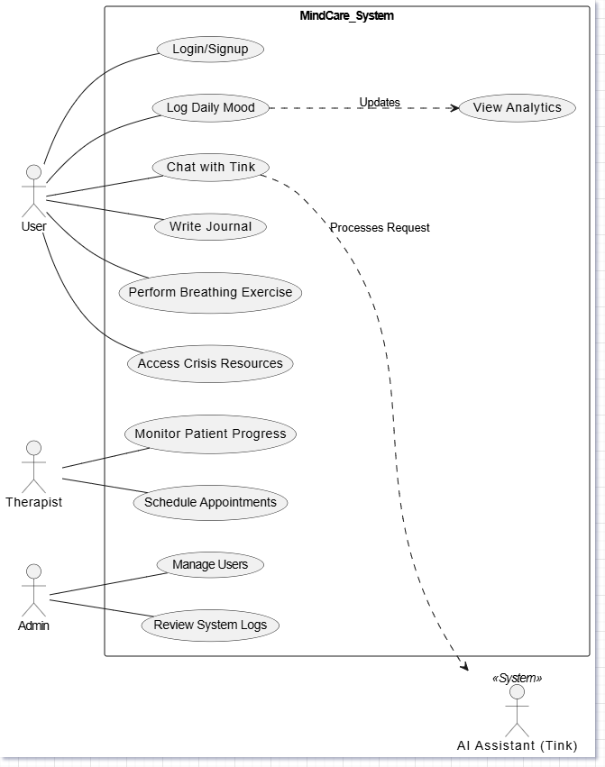

Fig. 3.1 Use Cases Model for the System

The use case diagram identifies the main functionality of the system. The primary actor is the user, who triggers events such as logging a mood or starting a chat. The AI ​​assistant (Tink) serves as a secondary system actor that processes these inputs to provide therapeutic grounding. The therapist actor interacts with the system to review longitudinal data, ensuring a hybrid care approach.

3.3. The Design Model

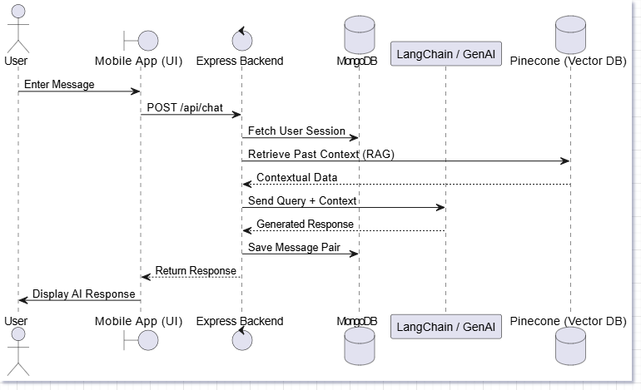

Fig. 3.2 Sequence

The design model is illustrated through a sequence diagram. It captures time-ordered interactions between system components. When a user sends a message, the system executes a "Retrieval Augmented Generation" (RAG) cycle. This involves deriving previous emotional context from the Pinecone Vector database before generating a response, ensuring that the interaction feels personal and sustained.

  - Object and Class Design

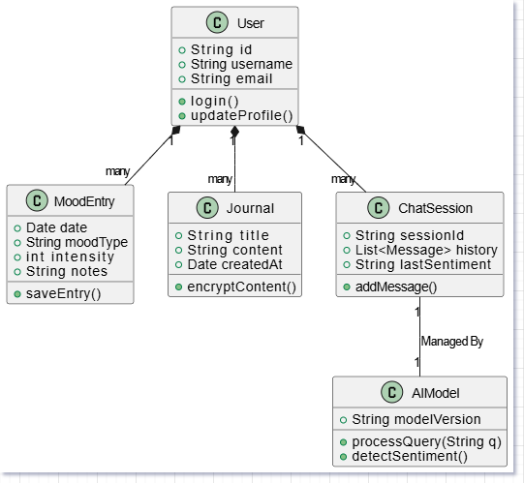

Fig. 3.3 Class Diagram

The class design represents the static structure of the MindCare database. The User class is the central entity, which has a one-to-many relationship with Moodlogs and Journals. This encapsulation ensures that user data is logically organized, allowing efficient queries when generating progress reports or sentiment trends.

3.5. State Transition

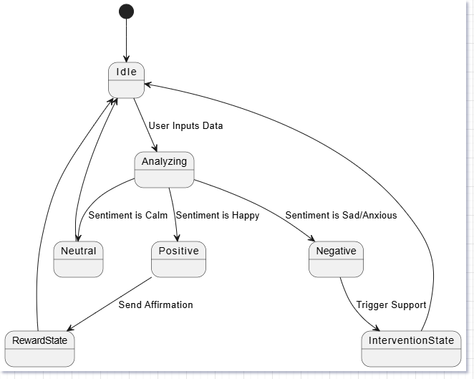

Fig. 3.4 State Transition: Mood Detection Behavior

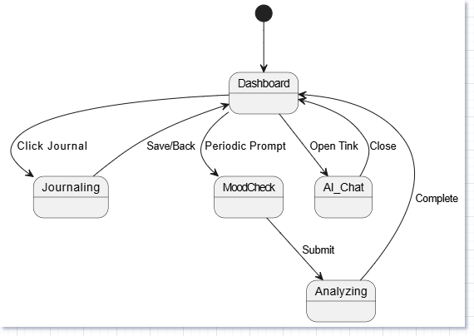

Fig. 3.5 State Transition: App Feature Navigation

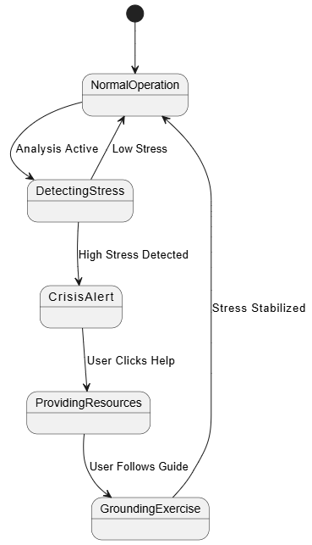

Fig. 3.6 State Transition: Crisis Interruption (Obstacle Avoidance)
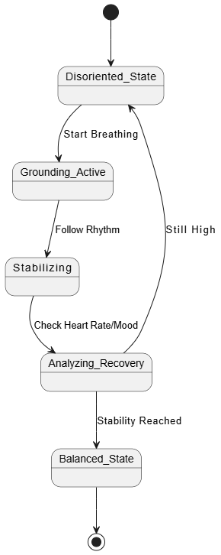

Fig. 3.7 State Transition: Emotional Recovery (Restoring Path)

System logic is controlled by several state machines:
- Mood detection (3.4): Transition between 'neutral', 'positive' and 'negative' based on NLP analysis.
- Finding Path (3.5): Manages the user's journey through various app modules (for example, from Dashboard to Therapy).
- Barrier resolution (3.6): This represents "crisis handling". If high voltage is detected, the app interrupts the normal flow to provide immediate grounding resources.
- Restoration Path (3.7): This represents the "recovery flow", which guides the user from the crisis state back to a balanced emotional baseline.

3.6. Activity Diagram

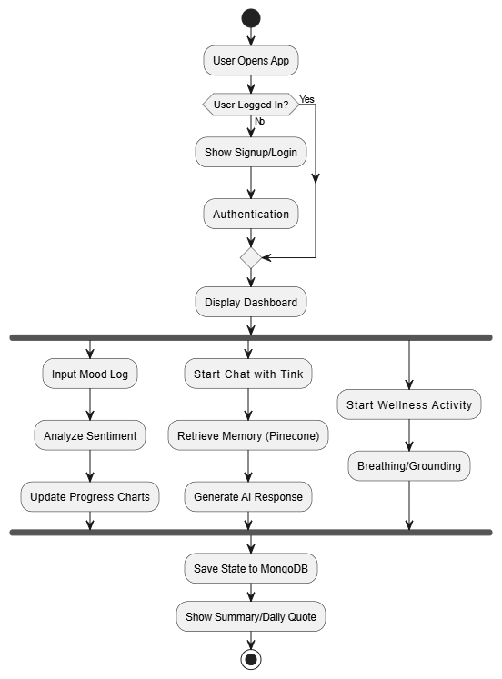

Fig. 3.8 Activity Diagram for the System

Activity diagrams provide the high-level workflow of a system's operational logic. It starts with authentication checks, followed by the main dashboard loop. The diagram highlights the parallel processing of mood logging and AI interactions, showing how the system concludes each session by saving the data in the MongoDB cloud and providing daily motivational results to the user.

- MINDCARE

4.1. MindCare Application Overview
MindCare is a holistic wellness platform designed to bridge the gap between traditional medicine and self-care. It provides a centralized hub for mood tracking, AI-powered conversations, and guided therapeutic exercises.
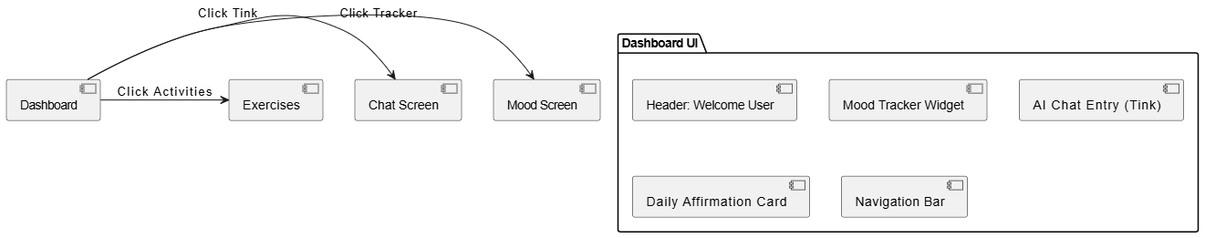

Fig. 4.1: MindCare App Logo and Dashboard

4.2. LangChain & GenAI – The System’s Brain

The “brain” of the MindCare system is an orchestration layer powered by Langchain. This layer connects the user interface to the larger language model, ensuring that interactions are structured and therapeutically based.

Technical Specifications
The system leverages the Gemini API for its core reasoning capabilities. The integration allows for high-speed Natural Language Processing and sentiment detection.

Knowledge Organization – Vector Database (Pinecone)
To ensure the AI has "long-term memory," MindCare uses a vector database. This organizes user data into mathematical vectors, allowing the AI to retrieve relevant past interactions to provide contextually accurate support.
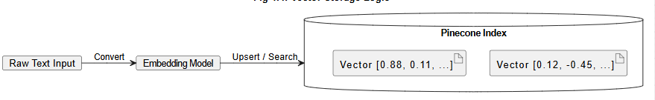

Fig. 4.2: Pinecone Vector Storage Structure

4.3. Developing the MindCare Environment
The development of MindCare utilizes a Node.js backend and a React Native frontend. The backend manages secure API routing and database connections.
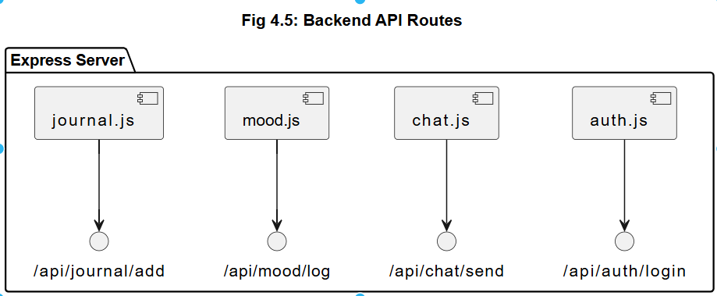

Fig. 4.3: Node.js Backend & API Routes

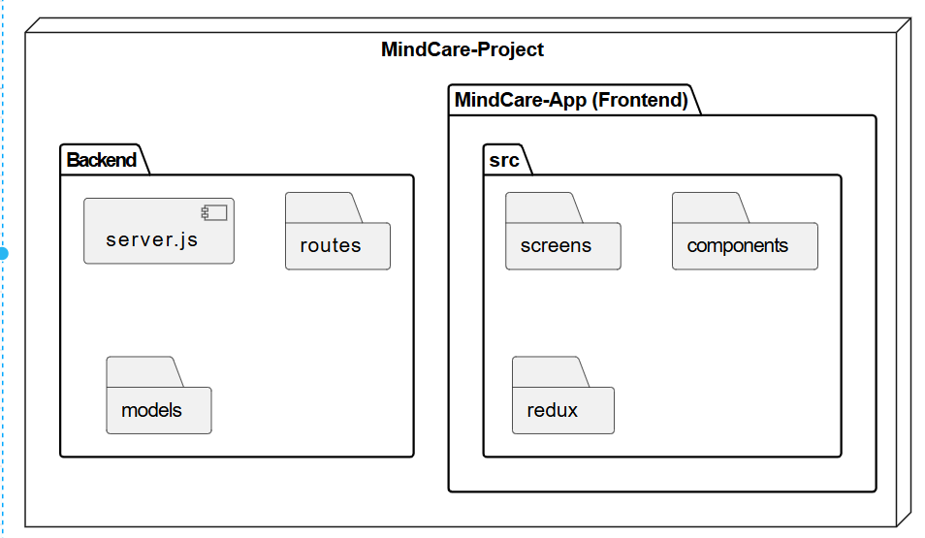

Fig. 4.4: React Native Codebase Structure

Environment Setup & Quick Start
Initializing the project requires running the Metro bundler to compile the JavaScript code for mobile deployment.
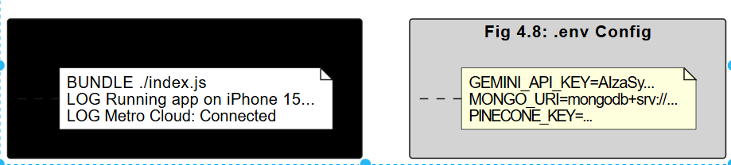

Fig. 4.5: Metro Bundler Console Output

Before running the app, environment variables must be configured to securely store the API keys for Langchain and MongoDB. [Insert Figure 4.8: configuring environment variables (.env) here]
The app is then deployed on an emulator or physical device for testing. [Insert Figure 4.9: Running app on Android/iOS emulator here]

During development, the debug terminal is used to monitor the live data exchange between the app and the AI server. [Insert Figure 4.10: Debug terminal displaying API responses here]

4.4. The Interaction Layer – React Native UI Components
The user interface is built using modular React Native components. These components ensure a smooth transition between screens, such as moving from the Dashboard to a Breathing Exercise. [Insert Fig. 4.11: User Interface (UI) Components & Navigation here]

4.5. The "Sensors" – Sentiment Analysis Engine
MindCare's primary way of "sensing" the user's state is through its sentiment analysis logic. This logic categorizes text into emotional zones to determine the type of support needed.
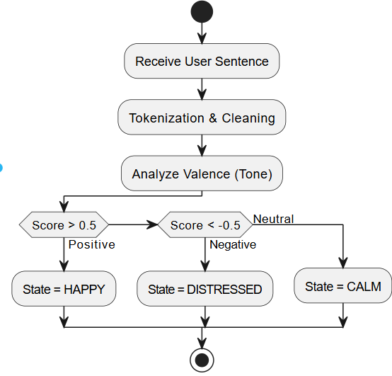

Fig. 4.6: Sentiment Detection Logic using NLP
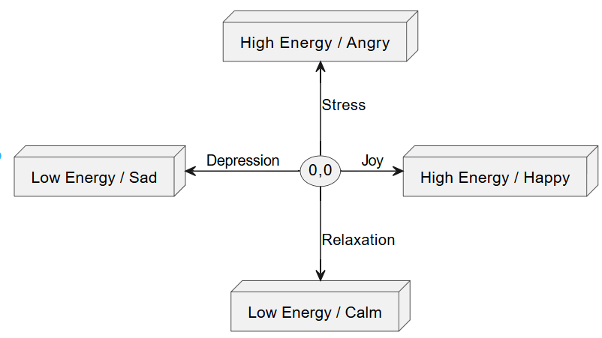

Fig. 4.7: Mood Intensity Mapping Graph

4.6. Real-time Monitoring – Threshold Detection
The system constantly monitors emotional "thresholds." If the sentiment analysis detects a score that indicates high distress, the system triggers an immediate safety intervention.
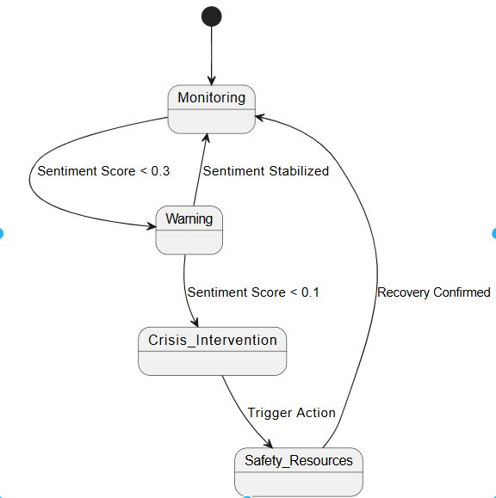

Fig. 4.8: Real-time Stress Level Threshold Monitor

- Implementation

5.1. Emotional State Mapping using Sentiment Scoring
In MindCare, "Path Tracing" refers to monitoring a user’s emotional baseline over time. Instead of Cartesian X and Y coordinates, we use Sentiment Valence (positive/negative) and Arousal/Intensity as our two-dimensional coordinate system to map the user's mental state.

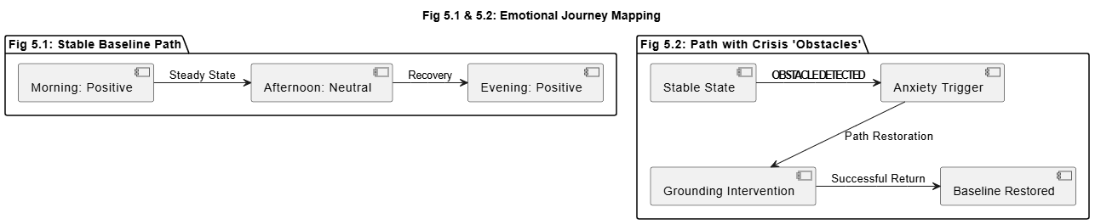

Fig. 5.1: Emotional Journey Graph (Stable baseline)

When a user faces stress or anxiety, these act as "obstacles" in their emotional path. The system must detect these peaks and provide a "restoration path" to bring the user back to their psychological baseline.



Fig. 5.2: Emotional Journey Graph (With crisis "obstacles")

5.2. Operational Scenarios
The implementation of MindCare is tested based on three primary scenarios:
- Daily Maintenance: Where the user is stable and requires regular tracking.
- Crisis intervention: where an acute decline in mood (a disturbance) is detected.
- Long-term recovery: Where the system scans past patterns to prevent future triggers.

5.3. Behavioral Algorithms

Algorithm 1: Sentiment-Based Support Selection This algorithm functions similarly to "Coordinate Based Seeking." It takes the current sentiment score (the "coordinate") and calculates the direct path to the most appropriate supportive response or grounding exercise.
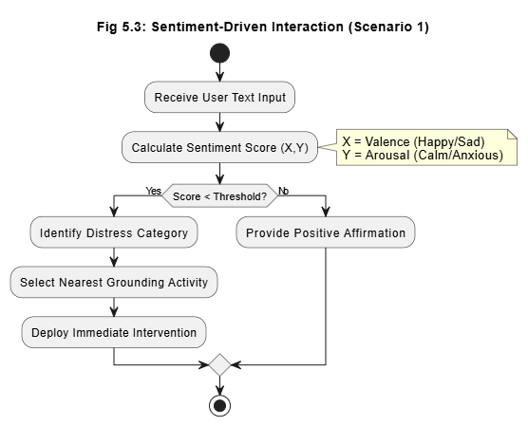

Fig. 5.3: Scenario-1: Direct Sentiment-Based Support Flow

Algorithm 2: Pattern-Based Activity Recommendation Similar to "Lookup Based Seeking," this algorithm does not just look at the current score but looks up the user’s history in the database. If the user previously found a "Breathing Exercise" helpful during a similar mood, the system prioritizes that recommendation.
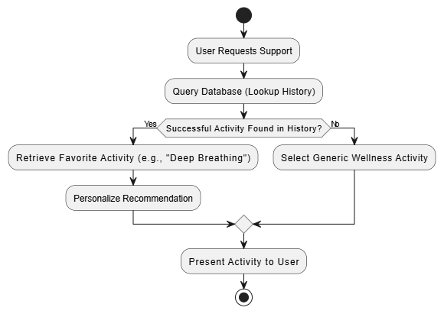

Fig. 5.4: Scenario-2: Pattern-Based Exercise Recommendation

Algorithm 3: Holistic Wellness Scanning Inspired by "Serpentine Scanning," this algorithm performs a comprehensive scan of all user inputs (Journals, Fitness logs, and Chat history). It weaves through these different data points to find "hidden" trends that a single mood log might miss, ensuring a holistic view of the user’s well-being.
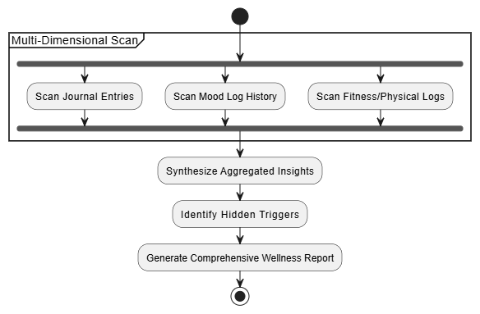

Fig. 5.5: Scenario-3: Holistic Scanning of User Metadata

- Output screens

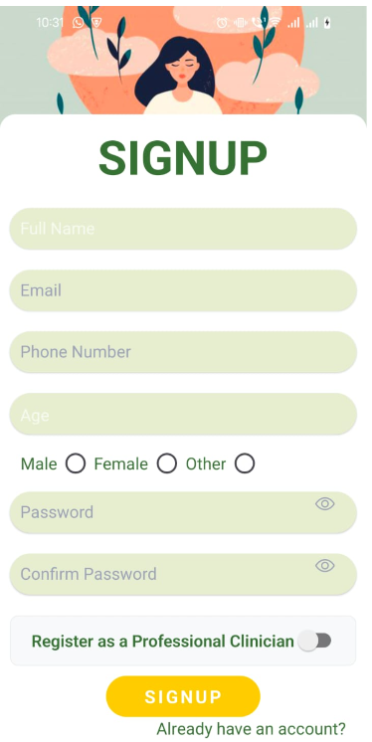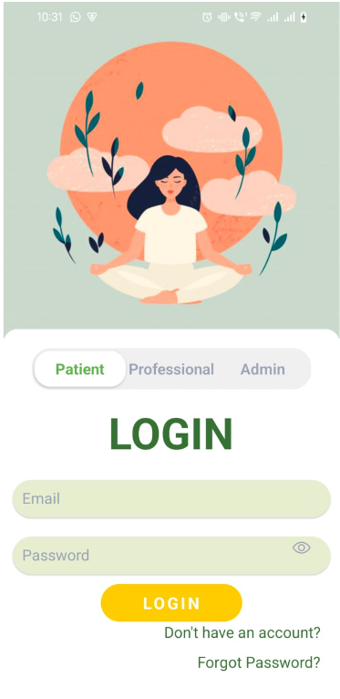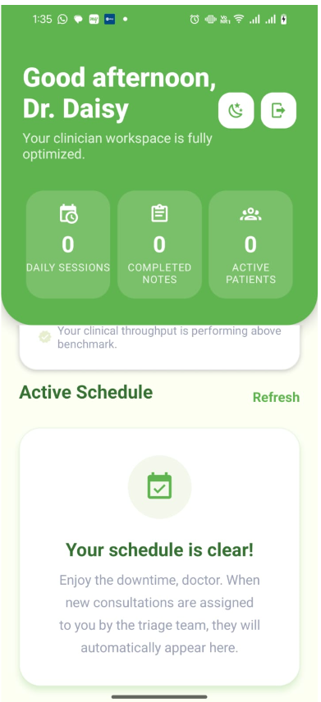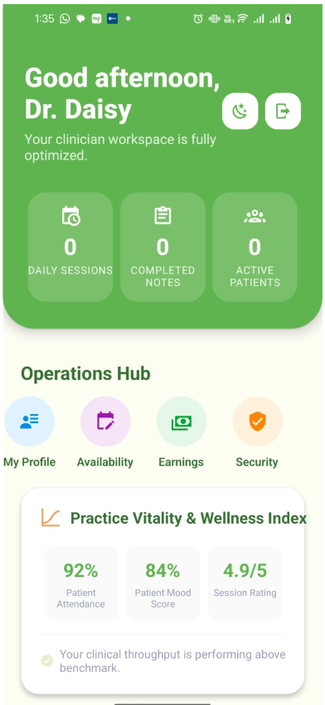

- Limitations and Future Enhancements

7.1. Current Limitations
While the MindCare application represents a significant step toward accessible digital mental healthcare, the current version of the system has several limitations that must be acknowledged:

- Dependency on Internet Connectivity
MindCare's core AI functionality, including the Tink chatbot and sentiment analysis engine, rely on continuous communication with the Google Gemini Pro API and Pinecone vector database hosted on a cloud server. As a result, the application cannot provide AI-powered medical assistance in an offline environment. Users in areas with poor network connectivity may experience poor performance or complete unavailability of the chatbot feature.

- Limited Emotional Nuance Detection
Current natural language processing (NLP) pipelines primarily perform sentiment classification into three broad categories: positive, neutral, and negative. This binary-adjacent approach may fail to capture complex, overlapping emotional states such as grief coupled with hope, anxious arousal, or functional depression – nuances that a trained human therapist would readily identify.

- Absence of Clinical Validation
MindCare is designed as a self-care and wellness tool, not a clinical diagnostic tool. This system has not been formally clinically tested or validated by licensed mental health professionals. AI responses, while empathetic, are not a substitute for certified therapy and may not be appropriate for users with serious psychiatric conditions such as schizophrenia, bipolar disorder, or active suicidal ideation.

- Data Privacy and Regulatory Constraints
The app collects sensitive personal health information, including mood logs, journal entries, and conversation histories. In the current prototype, strong compliance with healthcare data regulations like HIPAA (Health Insurance Portability and Accountability Act) or India's DPDPA (Digital Personal Data Protection Act, 2023) has not been fully implemented. This limits deployment of the system in regulated clinical environments.

- Scalability of the AI Model
The LangChain orchestration layer and Gemini Pro API integration were developed and tested for a limited number of concurrent users. As the user base scales, API rate limits, latency in Vector DB queries, and Node.js server bottlenecks may become significant challenges. The current architecture is not optimized for high-concurrency enterprise deployment.

- Personalization Depth
While MindCare tracks mood history, the AI does not yet build a truly longitudinal user model, one that adapts its therapeutic communication style, recommended exercises, and emotional tone based on weeks or months of interaction data. The context window is limited to recent sessions, meaning long-term behavioral patterns are not fully leveraged.

7.2. Future Enhancements
The following enhancements are proposed to address the current limitations and evolve MindCare into a more robust, clinically-informed, and globally accessible platform:

- Offline Mode with On-Device AI
A planned future enhancement is the integration of lightweight, on-device language models (such as Google's Gemini Nano or Meta's LLAMA) to enable core chatbot functionality without an Internet connection. This will make MindCare accessible to users in remote or low connectivity areas and improve overall application flexibility.

- Advanced Emotion Recognition
Future versions will incorporate multi-modal emotion detection, combining:
Facial Expression Analysis via the device camera (using models like MediaPipe or DeepFace)
Voice Tone Analysis using audio sentiment classification
Physiological Data Integration from wearables (e.g., heart rate from a smartwatch via Bluetooth)
This will allow MindCare to construct a far more accurate and holistic emotional profile of the user beyond text alone.

- Clinician-in-the-Loop Module
A Therapist Dashboard is envisioned where licensed mental health professionals can optionally monitor a consenting user's wellness trends (mood graphs, frequency of crisis flags) and schedule in-app video consultations. This creates a hybrid care model that bridges AI-assisted self-care with professional oversight.

- Healthcare Compliance and Security Hardening
Future releases will focus on achieving HIPAA and DPDPA compliance by implementing:
End-to-end encryption of all user health data (AES-256)
Role-based access control (RBAC) for any therapist/admin roles
Anonymous data storage options for sensitive journal entries
A dedicated Data Retention and Deletion Policy accessible to users

- Longitudinal Adaptive AI
The AI ​​engine will be enhanced to create and maintain consistent user memory models – tracking emotional baselines, trigger patterns, and progress over weeks and months. Using this data, the system will dynamically adapt its communication strategy, switching from soft incentives during stable periods to structured crisis-support protocols during recessions.

- Community and Social Wellness Features
Future iterations may introduce a moderated community support forum where users can anonymously share experiences and coping strategies. This peer-support layer, guided by AI moderation tools to flag harmful content, can foster a sense of belonging — a key factor in long-term mental wellness.

- Gamification and Engagement Mechanics
- To improve long-term user retention and consistent app usage — a known challenge in wellness apps — MindCare will introduce gamification elements such as:
- Wellness streaks and daily check-in rewards
- Achievement badges for completing therapeutic exercise sets
- A visual "wellness garden" that grows as the user engages with the app

- Multi-Language Support
To maximize accessibility across India's diverse linguistic landscape, future versions will support regional language interfaces including Hindi, Marathi, Gujarati, Tamil, and Bengali, with the AI chatbot capable of conducting therapeutic conversations in these languages using multilingual LLM fine-tuning.

- Conclusion

8.1. Summary of Work Done
The MindCare project was conceived with a singular and purposeful vision – to make mental health support universally accessible, stigma-free and available at any time of need. During this project, a full-stack, AI-powered mental wellness application was designed, developed, and evaluated. The application provides a safe and structured digital environment for users to manage their emotional well-being through daily mood tracking, AI-powered conversations, guided mindfulness exercises and personal journaling.
The system was built using a modern technology stack that included React Native for the cross-platform mobile frontend, a Node.js and Express framework for backend API management, Langchain as an AI orchestration layer, Google Gemini Pro as the main language model, and Pinecone as a vector database for long-term episodic memory. Together, these components create a cohesive and responsive system that places AI companion Tink at the center of the user experience, enabling empathetic, context-aware conversations that evolve with each interaction.

8.2. Achievement of Objectives
The primary objectives established at the beginning of this project have been successfully met. A cross-platform mobile application was designed and implemented, providing an accessible and intuitive interface for users on both Android and iOS platforms. The AI ​​chatbot Tink was successfully integrated using Langchain and the Google Gemini Pro API, enabling the system to generate empathetic and contextually relevant responses in real-time. A mood tracking module with historical data visualization was developed, allowing users to observe their emotional patterns over time and gain meaningful self-awareness.
Additionally, guided breathing and mindfulness exercises were incorporated to provide immediate, actionable coping mechanisms during moments of stress. A private journaling feature with built-in sentiment analysis was implemented to help users clarify their thoughts while the system passively monitors emotional trends. A secure Node.js backend with a RESTful API architecture was set up to support all application services, and a Pinecone vector database was integrated to provide the AI ​​with persistent, session-aware memory – which significantly improves the personalization and relevance of its responses.

8.3. Key Learnings
The development of MindCare provided deep practical insights into many advanced domains of software engineering and artificial intelligence. Working with large language models through the Langchain framework demonstrated the importance of rapid engineering – the careful design of instructions that guide the model toward clinically appropriate and safe responses. Implementing a retrieval-enhanced generation pipeline using PineCone showed how vector embeddings can dramatically improve the contextual accuracy and personalization of AI output beyond a standalone language model.
Cross-platform mobile development with React Native reinforced the value of component-based architecture and disciplined state management in building responsive and maintainable applications. Most importantly, working on the mental health platform has focused attention on the ethical responsibilities that come with building AI systems for vulnerable users. Safety guardrails, compassionate response design, and transparent communication of system limitations are not optional features – they are fundamental to any responsible AI application in the healthcare sector.

8.4. Social Impact and Relevance
Mental health, especially in developing countries, remains one of the most underfunded and underserved areas of public health. According to the World Health Organization, approximately one billion people globally are living with a mental disorder, yet the vast majority never receive any type of professional support. In India, the ratio of mental health professionals to the population is severely inadequate, leaving millions of people without access to the care they need. Social stigma, financial barriers and geographical inaccessibility further exacerbate this crisis.
MindCare is positioned as the first point of contact – not as a replacement for licensed therapists, but as a tool to democratize access to emotional support and self-awareness. By leveraging artificial intelligence to provide empathetic, around-the-clock support via mobile device, MindCare has the potential to reach students, working professionals, rural populations, and anyone who faces barriers to traditional mental health care. The project demonstrates that technology, when designed with compassion and intention, can serve as a powerful and meaningful instrument of social good.

8.5. Final Remarks
The MindCare application stands as a testament to the transformative potential of artificial intelligence in the field of health care and human well-being. It successfully combines the areas of natural language processing, mobile app development, and mental health awareness into one integrated platform. While the current version represents a functional and well-structured prototype, the architectural foundation laid through this project – its modular design, AI integration pipeline, vector memory system and user-centered philosophy – makes it suitable for iterative development into a production-grade wellness solution.
With continued development, clinical collaboration and regulatory compliance, MindCare aspires to evolve beyond an academic prototype into a trusted digital companion – one that walks with each individual in their journey towards better mental health. The belief driving this project is simple but profound: no one should face their struggles alone, and with the right technology, no one ever has to.

APPENDIX A: MINDCARE APPLICATION COMPONENTS AND CONFIGURATION

A.1. Overview
This appendix provides a detailed reference to the main technical components, libraries and configuration elements that make up the MindCare application. It serves as a supplemental guide for developers or evaluators who want to understand the system's internal setup, dependencies, and environmental requirements beyond those covered in the main chapters.

A.2. Frontend Components (React Native)
The MindCare mobile application is built using React Native, which enables a single codebase to run on both Android and iOS devices. The main frontend components include the authentication screen, which manages user login and registration; The Dashboard screen, which acts as a central hub displaying mood summaries and quick-access widgets; The Chat screen, which hosts the Tink AI chatbot interface; Mood Tracker screen, which allows users to log their daily emotional state using an intuitive scale; Journal Screen, which provides a personal text editor for reflective writing; and the exercise screen, which guides users through breathing and mindfulness activities. Each screen is built as an independent, reusable React Native component and connected through a centralized navigation stack managed by React Navigation.

A.3. Backend Components (Node.js / Express)
MindCare's backend is a RESTful API server built with Node.js and the Express framework. Its primary components include the authentication module, which handles user registration, login, and JWT token validation; Chat controller, which receives user messages and forwards them to the Langchain orchestration pipeline; Mood Controller, which manages the storage and retrieval of mood log entries from the database; and the journal controller, which handles securely saving and retrieving journal entries. All API routes are versioned and protected using middleware-based authentication to ensure that only authorized users can access personal health data.

A.4. AI Integration Components
MindCare's intelligence layer consists of three tightly connected components. The Langchain Orchestrator acts as the central coordinator, receiving user input, retrieving relevant context, and building structured signals for the language model. The Google Gemini Pro API serves as the generative language model responsible for producing empathetic and therapeutically tailored responses. The Pinecone vector database stores embedded representations of past conversations, enabling the system to retrieve contextually relevant history and provide consistent and personalized responses across multiple sessions.

A.5. Environment Configuration (.env)
The MindCare application depends on the following key environmental variables for its operation. These are stored in a .env file at the root of the backend directory and must be configured correctly before the server starts.
port=5000
MONGO_URI=your_mongodb_connection_string
JWT_SECRET=your_jwt_secret_key
GEMINI_API_KEY=your_google_gemini_api_key
PINECONE_API_KEY=your_pinecone_api_key
PINECONE_ENVIRONMENT=your_pinecone_environment_name
PINECONE_INDEX=mindcare-memory

These variables ensure that all third-party service connections remain secure and are not hardcoded into the application source code.

A.6. Key Dependencies and Libraries
Following are the major packages and libraries used in MindCare system:
Frontend (React Native): react-native, @react-navigation/native, @react-navigation/stack, axios, react-native-async-storage, react-native-vector-icon, react-native-chart-kit
Backend (Node.js): express, mongoose, jsonwebtoken, bcryptjs, dotenv, cors, langchen, @google/generative-ai, @pinecone-database/pinecone.

A.7. System Requirements
To run the MindCare application in a local development environment, the following minimum system requirements must be met. Node.js version 18 or above must be installed on the host machine. Android Studio or Xcode is required to run mobile applications on an emulator or physical device. A stable Internet connection is required for communication with the Google Gemini Pro API and the Pinecone vector database. A valid MongoDB instance, either local or cloud-hosted through MongoDB Atlas, is required to store user and application data.

APPENDIX B: API RESPONSE CODES AND ERROR REFERENCE

B.1. Overview
Just as resistor color codes serve as a standard reference for identifying electronic component values, this appendix serves as a standard reference guide for HTTP response codes and custom error messages used in the MindCare backend API. Developers and testers can use this appendix to quickly identify the meaning of any response received from MindCare Server during development, debugging, or integration.

B.2. Standard HTTP Status Codes Used in MindCare
The MindCare backend follows standard HTTP response code conventions for all API communication between the mobile client and the Node.js server.
- 200 – OK: The request was successful. The server has returned the expected data. This response is sent when a user successfully logs in, retrieves mood history, or receives a chatbot response.
- 201 – Created: A new resource was successfully created. This response is returned when a user registers a new account, saves a new mood log entry, or creates a new journal entry.
- 400 – Bad Request: The server could not process the request due to invalid or missing input data. This response is returned when required fields such as email, password, or message content are not provided in the request body.
- 401 – Unauthorized: The request lacks valid authentication credentials. This response is returned when a user attempts to access a protected route without a valid JWT token or when the token has expired.
- 403 – Forbidden: The authenticated user does not have permission to access the requested resource. This response is returned when a user attempts to access another user's journal entries or mood data.
- 404 – Not Found: The requested resource does not exist on the server. This response is returned when a user ID, mood log ID, or journal entry ID cannot be found in the database.
- 500 – Internal Server Error: An unexpected error occurred on the server side. This is typically returned when the database connection fails, the Gemini API is unreachable, or an unhandled exception occurs in the application logic.

B.3. Custom MindCare Error Messages
In addition to standard HTTP codes, the MindCare API returns descriptive custom error messages in JSON format to assist developers in diagnosing issues quickly.
json
{ "error": "User already exists. Please login." }
{ "error": "Invalid credentials. Please check your email and password." }
{ "error": "Token expired. Please login again." }
{ "error": "Message cannot be empty." }
{ "error": "AI service is currently unavailable. Please try again later." }
{ "error": "Failed to connect to memory database. Context retrieval skipped." }
{ "error": "Mood score must be between 1 and 10." }
{ "error": "Journal entry exceeds maximum character limit." }

B.4. Gemini API Response States
When the MindCare backend communicates with Google Gemini Pro API via Langchain, the following response status may be encountered:
- Success – The model returned a valid, complete response. The chatbot's reply is sent to the user.
- Blocked – The model marked an input or output as potentially unsafe based on its content security filters. MindCare handles this by returning a default empathetic fallback message to the user.
- Timeout – The API did not respond within the configured time limit. MindCare retries the request once before returning a service unavailable message.
- RATE_LIMITED – API request quota exceeded. This occurs during high-traffic periods and is addressed in future growth planning via request queuing
.

APPENDIX C: DEVELOPMENT GUIDELINES AND BEST PRACTICES

C.1. Overview
Just as breadboarding rules define the correct method of connecting electronic components to avoid short circuits and damage, the development guidelines outlined in this appendix define the correct practices that should be followed when building, expanding, or modifying a MindCare application. Following these rules ensures that the system remains stable, secure, and maintainable throughout its development lifecycle.

C.2. Environment Setup Rules
Before starting any development work on the MindCare application, the following rules should be strictly followed.
Never hardcode API keys, database credentials, or secret tokens directly into source code. All sensitive configuration values ​​should be stored in a .env file located at the root of the backend directory. This file should never be committed to a version control system like Git. The .gitignore file should always include.env to prevent accidental exposure of credentials.
The Node.js version used during development must be version 18 or above. Using an older version may cause compatibility issues with the Langchain and Pinecone libraries. Always verify the Node.js version by running node -v in the terminal before starting the server.
The pinecone index must be built with the correct vector dimensions that match the embedding model being used. All vector storage and retrieval operations will silently fail due to mismatched dimensions.

C.3. Backend Development Rules
All API routes should be protected using JWT authentication middleware, unless the routes are explicitly intended to be public, such as login and registration endpoints. Adding a new route without implementing authentication guards is a serious security breach.
Each controller function must implement proper error handling using a try-catch block. Rejecting an unfulfilled promise in an Express application can cause the entire server to crash. All captured errors MUST return a meaningful HTTP status code and a descriptive JSON error message as defined in Appendix B.
Database queries should never be performed directly inside route definitions. All database logic should be contained within an appropriate controller or service file to maintain clear separation of concerns and improve testability.

C.4. AI Integration Rules
When creating prompts for the Google Gemini Pro API via Langchain, always include a system-level directive that establishes Tink's therapeutic and empathetic personality. Sending raw user messages without system prompts may result in normal or medically inappropriate responses.
The Pinecone vector database must be queried before each AI response generation to retrieve relevant previous context. Skipping this step will cause the chatbot to lose memory of previous sessions and degrade the personalization quality of the interaction.
Always implement a fallback response mechanism in the chat controller. If the Gemini API returns a blocked or failed response, the system should return a pre-defined, safe and empathetic fallback message to the user rather than displaying a raw error.

C.5. Frontend Development Rules
All API calls from the React Native frontend must be made through a centralized Axios service file. API base URLs and headers should never be spread across different screen components. This ensures that changing the backend URL requires modification in only one place.
The user authentication token received after login should be stored securely using React Native AsyncStorage. Tokens should never be stored in component state or local variables, as they will be lost when the application is restarted.
All screens requiring user authentication must verify the presence of a valid token before rendering their content. If no token is found, the user should be immediately redirected to the login screen.

C.6. General Coding Rules
All functions, components and modules should be given clear, descriptive names that reflect their purpose. Single-letter variable names and ambiguous function names such as doStuff() or HandleData() are not acceptable.
Code should be commented wherever the logic is not clear, especially in AI orchestration pipelines and sentiment analysis modules. Comments should explain the purpose of the block of code, not just explain what the code does.
Before pushing any new code, the developer must test all affected API endpoints using a tool like Postman and verify that the mobile application renders correctly on both Android and iOS emulators. Any unused code should not be merged into the main branch.

REFERENCES

[1] World Health Organization, "World Mental Health Report: Transforming Mental Health for All," WHO Press, Geneva, Switzerland, 2022. [Online]. Available: https://www.who.int/publications/i/item/9789240049338
[2] A. Torous, J. Myrick, K. Rauseo-Ricupero, and J. Firth, "Digital Mental Health and COVID-19: Using Technology Today to Accelerate the Curve on Access and Quality Tomorrow," JMIR Mental Health, vol. 7, no. 3, 2020.
[3] React Native Documentation, "Introduction to React Native," Meta Open Source, 2023. [Online]. Available: https://reactnative.dev/docs/getting-started
[4] Node.js Foundation, "Node.js Official Documentation," OpenJS Foundation, 2023. [Online]. Available: https://nodejs.org/en/docs
[5] Express.js, "Express — Node.js Web Application Framework," OpenJS Foundation, 2023. [Online]. Available: https://expressjs.com
[6] LangChain, "LangChain Documentation: Building Applications with LLMs," LangChain Inc., 2023. [Online]. Available: https://docs.langchain.com
[7] Google DeepMind, "Gemini: A Family of Highly Capable Multimodal Models," Google AI, 2023. [Online]. Available: https://deepmind.google/technologies/gemini
[8] Pinecone Systems Inc., "Pinecone Vector Database Documentation," 2023. [Online]. Available: https://docs.pinecone.io
[9] MongoDB Inc., "MongoDB Documentation: The Developer Data Platform," 2023. [Online]. Available: https://www.mongodb.com/docs
[10] P. Lewis et al., "Retrieval-Augmented Generation for Knowledge-Intensive NLP Tasks," Advances in Neural Information Processing Systems (NeurIPS), vol. 33, pp. 9459–9474, 2020.
[11] J. Woebot Health, "Delivering Cognitive Behavioral Therapy to Young Adults with Symptoms of Depression and Anxiety Using a Fully Automated Conversational Agent," JMIR Mental Health, vol. 4, no. 2, 2017.
[12] React Navigation, "React Navigation Documentation: Routing and Navigation for React Native," Software Mansion, 2023. [Online]. Available: https://reactnavigation.org/docs/getting-started
[13] Axios, "Axios HTTP Client Documentation," 2023. [Online]. Available: https://axios-http.com/docs/intro
[14] JSON Web Tokens, "Introduction to JSON Web Tokens," Auth0 Inc., 2023. [Online]. Available: https://jwt.io/introduction
[15] bcrypt.js, "bcryptjs — Password Hashing Library for Node.js," npm Registry, 2023. [Online]. Available: https://www.npmjs.com/package/bcryptjs
[16] B. Liu, "Sentiment Analysis and Opinion Mining," Synthesis Lectures on Human Language Technologies, Morgan & Claypool Publishers, vol. 5, no. 1, pp. 1–167, 2012.
[17] Government of India, "The Digital Personal Data Protection Act, 2023," Ministry of Electronics and Information Technology, New Delhi, 2023. [Online]. Available: https://www.meity.gov.in
[18] U.S. Department of Health and Human Services, "Health Insurance Portability and Accountability Act (HIPAA)," 1996. [Online]. Available: https://www.hhs.gov/hipaa
[19] T. Brown et al., "Language Models are Few-Shot Learners," Advances in Neural Information Processing Systems (NeurIPS), vol. 33, pp. 1877–1901, 2020.
[20] A. Vaswani et al., "Attention Is All You Need," Advances in Neural Information Processing Systems (NeurIPS), vol. 30, 2017.

